**Name………………………………………………… Admission No…………………………………..**

**Student’s signature…………………………. Date…………….…………………………….…..**

**FANAKA GIRLS HIGH SCHOOL**

**DECEMBER HOLYDAY ASSIGNMENT**

**BIOLOGY**

**FORM 3**

**INSTRUCTIONS TO STUDENTS**

1. **Write your name and admission number in the spaces provided above.**
2. **Answer all the questions in this question paper.**
   * + 1. The diagram below represents gaseous exchange alveolus

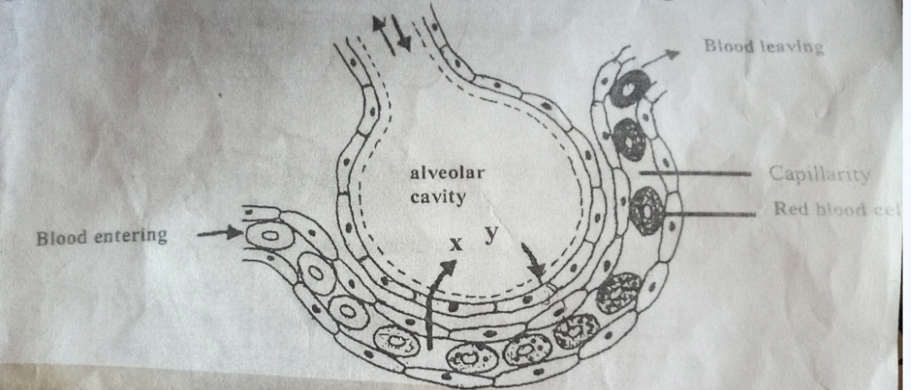

1. Identify the gases labelled X and Y (2mks)
2. Trace the path followed by gas Y from the alveolar space until it reaches the red blood cells.

(3mks)

1. Name the part of the brain that controls breathing movement in humans. (1mk)
2. List two features of gaseous exchange surfaces in animals that are evident in the diagram above.

(2mks)

1. The diagram below represent set up to investigate the conditions necessary for seed germination.

The set up was left for 5 days.

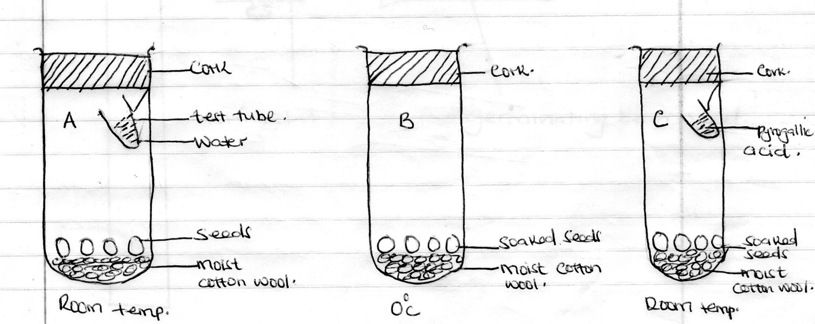

1. What conditions were being investigated in the experiment. (2mks)
2. Explain the role of water during seed germination. (2mks)
3. State observation made in jar A and C after five days. (2mks)
4. Account for the results obtained in set up A and C after five days. (2mks)
5. Below is a food web. Study it and answer questions that follow

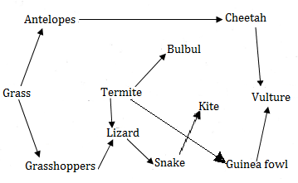

1. Write two food chains in which the guinea fowls are secondary consumers (2mks)
2. Which organism has the largest variety of predators in the food web (1mk)
3. Name the tertiary consumer in the food web (1mk)
4. Name the organism through which energy from the sun enters the food web (1mk)
5. What would be the short term effect on the ecosystem if leopards invaded the area (1mk)
6. Suggest two ways in which the ecosystem would be affected if there was prolonged drought(2mks)
7. A set up was done as shown below

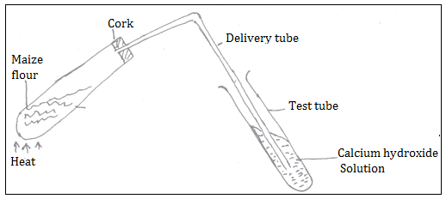

1. What was the aim of the experiment? (1mk)
2. State two observations in the test tube (2mks)
3. State an observation in the boiling tube (1mk)
4. List two conclusions made at the end of the experiment (2mks)
5. A man weighing 90kg requires 200KJ per gram of body weight while a rat weighing 50g requires 2500KJ per gram of body weight. Explain (2mks)
6. An experiment was set up as shown below to investigate a condition necessary for photosynthesis.

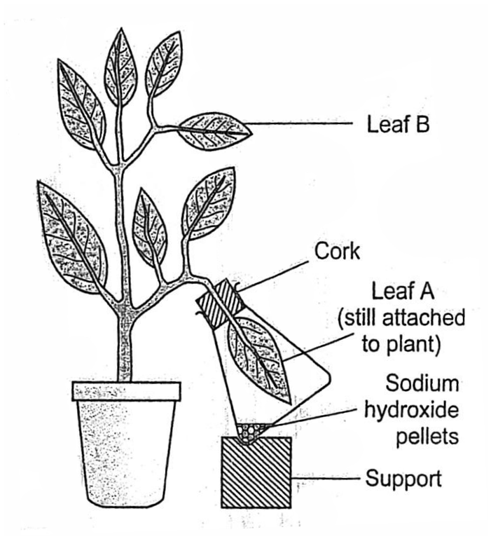

1. What condition was being investigated? (1 mark)
2. What is the role of sodium hydroxide pellets? (1 mark)
3. Explain the expected results when leaf A and leaf B are tested for starch. (4 marks)
4. Why was leaf B also tested for starch? (1 mark)
5. Other than the condition being investigated, name any other condition. (1 mark)

**SECTION B (40 MARKS)**

***Answer questions 6 (compulsory) and either question 7 or 8 in the spaces provided after question 8***

1. The length of a grasshopper femur and internode of a seedling were recorded in a period of 24 weeks. The results are recorded in the table below.

|  |  |  |  |  |  |  |  |  |  |  |
| --- | --- | --- | --- | --- | --- | --- | --- | --- | --- | --- |
| **Week** | **1** | **3** | **5** | **7** | **10** | **13** | **16** | **18** | **20** | **24** |
| **Average length of femur** | **8.0** | **9.0** | **9.0** | **9.0** | **13.0** | **13.0** | **15.0** | **19.0** | **19.0** | **19.0** |
| **Average length of internode(mm)** | **5.0** | **6.5** | **10.5** | **16.5** | **24.5** | **27.5** | **32.5** | **34.5** | **36.0** | **37.5** |

1. Plot a graph of length of femur and length internode against time on the same axis. (7mks)



1. (i)What was the average length of internode in the 8th week? (1mk)

(ii)Suggest how average length of internodes was obtained. (2mks)

1. Name the type of growth curve shown by

i) Grasshopper (1mk)

ii) Seedling (1mk)

1. Account for the change in length for fermur between

i) 3rd and 7th week (2mks)

ii) 16th and 20th week (2mks)

1. State what causes increase in length of internodes in the seedling. (2mks)
2. Which animal phylum exhibits the growth pattern of the fermur. (1mks)
3. Name the hormone responsible for the growth pattern in grasshopper. (1mks)
4. Work out the rate of growth of the seedling between week 7 to 10 (2mks)

***Answer either question 7 or 8 in the foolscap provided***

1. a)Describe the menstrual cycle process in humans 19 mks

b) State the fertile period during the menstrual cycle. (1mk)

8. a) Describe the various factors affecting transpiration rate in plants 10mks

b) Describe the process of photosynthesis 10 mks